Central Minnesota Irrigators
Keith Olander
Executive Director, AgCentric & Agricultural Partnerships
keith.olander@clcmn.edu
763-257-2881

Todd Pollema
Farm Manager
todd.pollema@clcmn.edu
218-296-0414

Taylor Thompson
Farm Technician
taylor.thompson@clcmn.edu
218-894-5100

Tyler Grunewald
Ag Program Coordinator
tyler.grunewald@clcmn.edu
218-894-5141

Melody Weber
Administrative Assistant
melody.weber@clcmn.edu
218-894-5123

“Educational Projects” Grant Opportunity
April 21, 2026

This letter is to request proposals for funding educational projects in the classroom that focus on conservation, sustainability, precision agriculture, or production of food as they relate to water resources. The request amount can be up to $750.00 (awarded amount determined by the board). CMI will award up to $1,500 in grants. Our mission is to educate, inform and promote research irrigation techniques.
Apply online at https://centralmnirrigators.org/educational-projects-grant-opportunity/
The following information is required when applying:
- School/organization name.
- Contact person with contact information (address, title, phone)
- What is the title and purpose of the project?
- How will students be engaged in the project?
- What are the outcomes of the project?
- How does this project fit with other work/education you are doing?
- What is the project timeline? (project needs to be completed by 4/1/27)
- How will the project contribute to consumer/student literacy about agriculture?
- What are the items of the project budget?
Application deadline: July 31, 2026
Please email keith.olander@clcmn.edu or call 763-257-2881 with questions regarding this request for proposals. Awards will be determined at the August board meeting and awardees notified thereafter. All awardees will be asked to present in person or via technology about the intended use of funds at the annual CMIC meeting in January 2027 (5-10 minutes).

Sincerely,
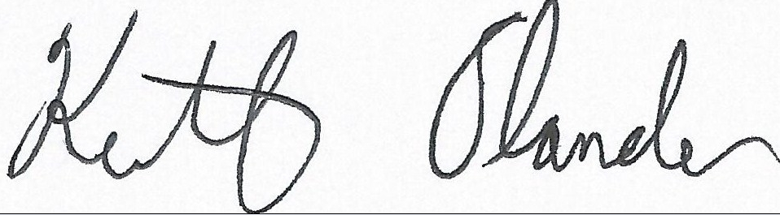
Keith Olander
Director of Ag & Energy/Farm Business Management
Central Lakes College

